1] Create Repository
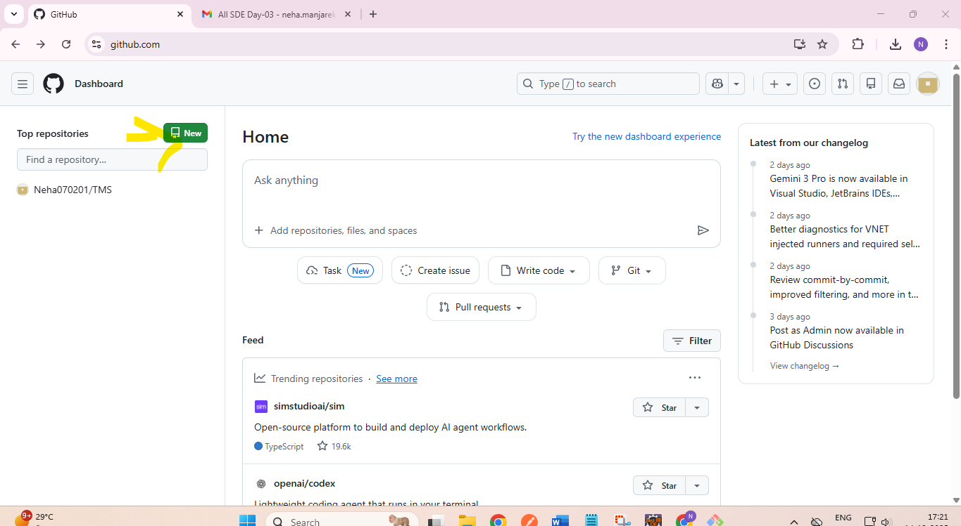
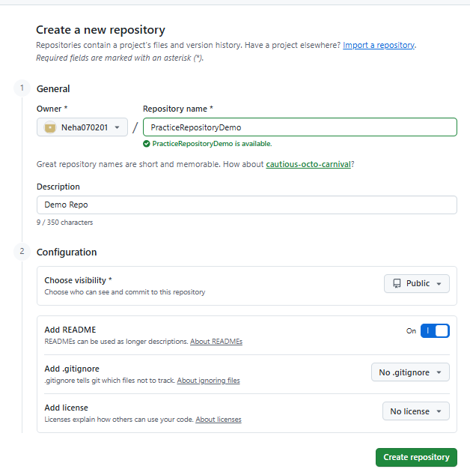

2] Update readme file -> click on
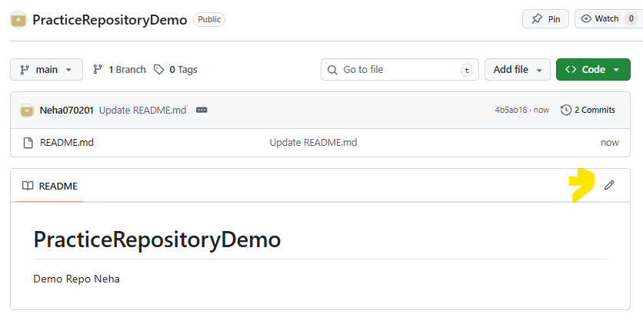
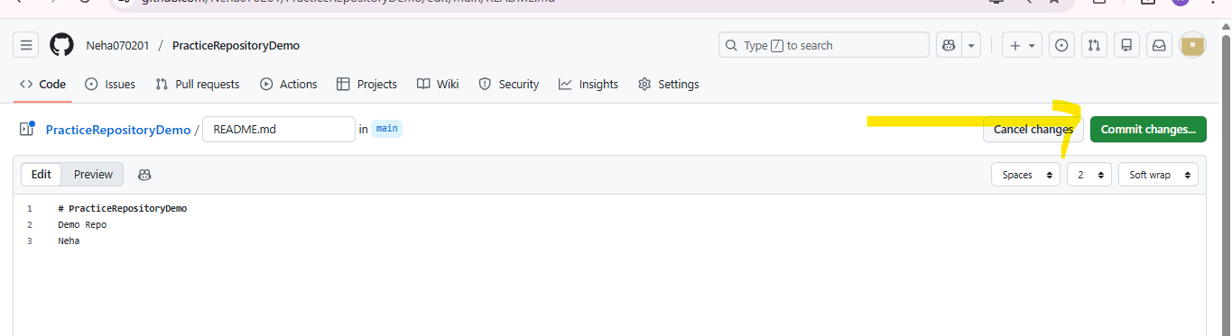
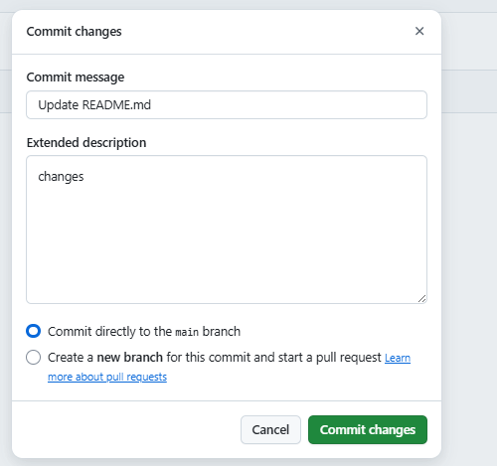

3] Delete Repository -> scroll down at last
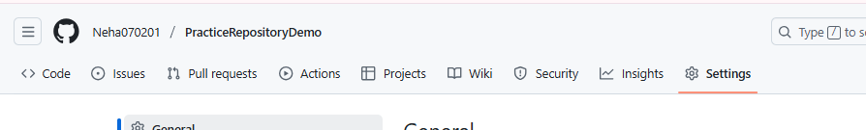
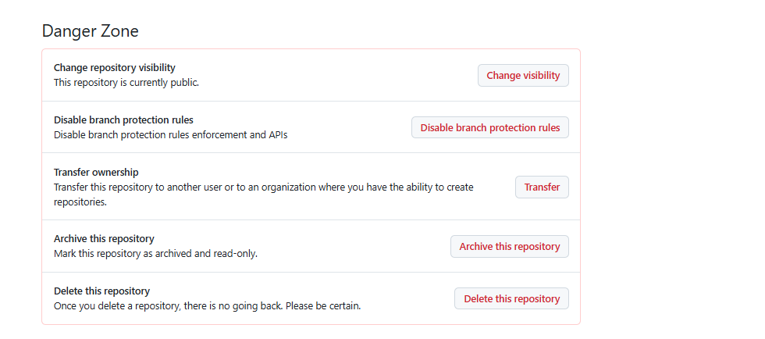

4] Upload Files
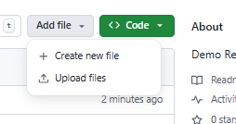

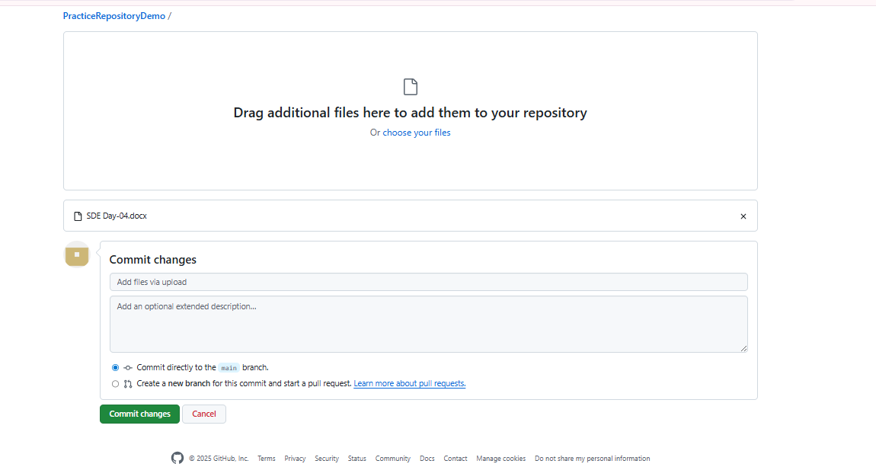

5] Git Clone from server to Local
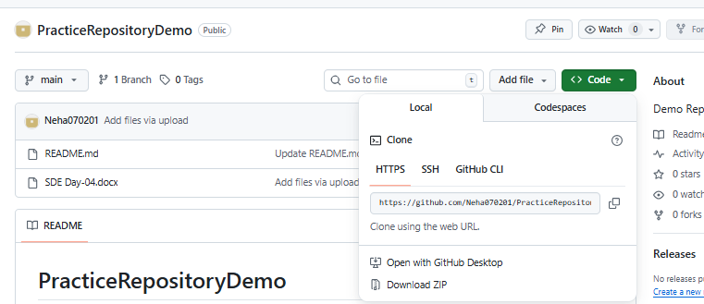

Open vscode:-

Bash from terminal open in particular folder example d Drive

Copy the url after git clone

dac28@DAC28 MINGW64 /d/web

$ git clone https://github.com/Neha070201/PracticeRepositoryDemo.git
Cloning into 'PracticeRepositoryDemo'...
remote: Enumerating objects: 9, done.
remote: Counting objects: 100% (9/9), done.
remote: Compressing objects: 100% (5/5), done.
remote: Total 9 (delta 0), reused 0 (delta 0), pack-reused 0 (from 0)
Receiving objects: 100% (9/9), 689.67 KiB | 29.99 MiB/s, done.

dac28@DAC28 MINGW64 /d/web

$ git status
fatal: not a git repository (or any of the parent directories): .git

dac28@DAC28 MINGW64 /d/web

$ cd PracticeRepositoryDemo

IMP:-Then change in The local repo

dac28@DAC28 MINGW64 /d/web/PracticeRepositoryDemo (main)

$ git status
On branch main
Your branch is up to date with 'origin/main'.

Changes not staged for commit:
(use "git add <file>..." to update what will be committed)
(use "git restore <file>..." to discard changes in working directory)
modified: README.md

no changes added to commit (use "git add" and/or "git commit -a")

dac28@DAC28 MINGW64 /d/web/PracticeRepositoryDemo (main)

dac28@DAC28 MINGW64 /d/web/PracticeRepositoryDemo (main)

$ git add .
dac28@DAC28 MINGW64 /d/web/PracticeRepositoryDemo (main)

$ git commit -m "Changes from Local Machine"
[main d3858d8] Changes from Local Machine
Committer: dac28 <dac28@met.edu>
Your name and email address were configured automatically based
on your username and hostname. Please check that they are accurate.
You can suppress this message by setting them explicitly. Run the
following command and follow the instructions in your editor to edit
your configuration file:

git config --global --edit

After doing this, you may fix the identity used for this commit with:

git commit --amend --reset-author

1 file changed, 2 insertions(+)

6] Changes upload from local to server

dac28@DAC28 MINGW64 /d/web/PracticeRepositoryDemo (main)

$ git push origin main
Enumerating objects: 5, done.
Counting objects: 100% (5/5), done.
Delta compression using up to 8 threads
Compressing objects: 100% (2/2), done.
Writing objects: 100% (3/3), 325 bytes | 325.00 KiB/s, done.
Total 3 (delta 0), reused 0 (delta 0), pack-reused 0 (from 0)
To https://github.com/Neha070201/PracticeRepositoryDemo.git
a557640..d3858d8 main -> main

7] Now Check on Server GitHub: -Changes reflected
